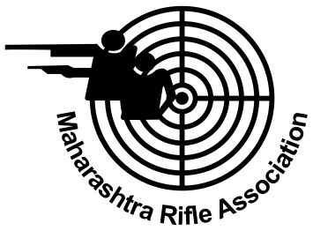

THE MAHARASHTRA RIFLE ASSOCIATION

Affiliated To the National Rifle Association of India & Maharashtra Olympic Association

(Public Trust & Society Reg. No. F-6615 (BOM) Dt. 25-03-1981)

S. No. : MSSC / CERT / 190 Date : 25/02/2017

**Certificate**

Certified that _________ **Resham Kaur Kewalramani**________ of **_________________ Mumbai City____________________________** has participated in the **33rd** **Maharashtra State Shooting Championship** organized by Maharashtra Rifle Association and conducted by the Mumbai City District Rifle Association, held at **Mumbai**

from 28/09 / 2016 to 05 /10/ 2016 and obtained the following results:

**S. No. Event Score Position Remark**

**1. 10M Air Rifle Youth Women 362** ----

**Hon. Gen. Secretary**

**Sheila Kanungo**